Certificated Squad Pack SOW

Optimization

Versión 1.0
7 de may 2024
By: Uriel Agustín Grosso – Pre-Sales Solutions Architect

Index
Index 1
Introduction 2
Why have a certified AWS team from BigCheese? 3
What type of companies should hire this service? 4
- Have a small or overloaded technical team 4
- Are already moving to the cloud but need to accelerate 4
- Have accumulated technical debt and need to bring order 5
- Have key initiatives blocked due to lack of resources 5
- Want to professionalize their cloud practice 5
Business Case: More Capacity, Less Friction 5
Objective 7
What We Need from BigCheese for a Successful Certified Squad 7
Service Scope 8
Success Criteria 10
Deliverables 11
Team involved 13
Plan de acción 14
Cronograma estimado 15
What happens after the 3-month Squad engagement? 17

Introduction
Our team, your Squad
At BigCheese, AWS Premier Partner, we know that many organizations want to modernize, automate, and scale their cloud operations, however, they face a common reality: they don’t always have the time, team, or expertise to do it properly and on time.
That’s why we apply our Think Big, Start Small approach:
- Think Big means envisioning an agile, secure, and automated infrastructure that supports business growth.
- Start Small means beginning with focus: a certified technical team, immediately available, that can support your team or get the job done directly.
With Certified Squad, you’re not hiring isolated consultants or adding operational burden: you’re gaining a full team of AWS-certified experts (architecture, security, automation, data, DevOps, and FinOps) who integrate with your operations for three months to:
- Reduce your in-house team’s learning curve
- Lead and execute key tasks your team can’t currently tackle
- Unblock technical projects stuck due to lack of time or resources
- Accelerate the adoption of best practices without having to train from scratch
This approach has three key advantages:
- You don’t interrupt your operation: you add capabilities without slowing down what you already do
- You don’t need to wait months to hire complex profiles
- You deliver value from the first week, with visibility, focus, and results

Transforming your technical operations doesn’t require bloating your structures: with BigCheese, your team grows in capacity, not in complexity.

Why have a certified AWS team from BigCheese?
At BigCheese, we are an AWS Premier Partner, the highest level of collaboration with Amazon Web Services worldwide.
We are over 100 cloud specialists, and 100% of our team is AWS certified. This complete specialization, without multicloud distractions or generic solutions, allows us to reach a unique level of technical depth, fully aligned with AWS ecosystem best practices.
Having a certified team from BigCheese isn’t just about hiring consultants: it’s about bringing in high-level technical capabilities, ready to execute, document, transfer knowledge, and help you scale smoothly.
Over the years, we’ve supported dozens of companies across multiple industries; finance, retail, healthcare, technology, logistics, helping them solve real challenges with concrete results in performance, security, automation, visibility, and operational efficiency.
With Certified Squad, we don’t give you recommendations from the outside: we work with you, from the inside, with focus, methodology, and commitment.

Because in the cloud world, the difference isn’t just knowing what to do, it’s doing it well, fast, and with real backing.
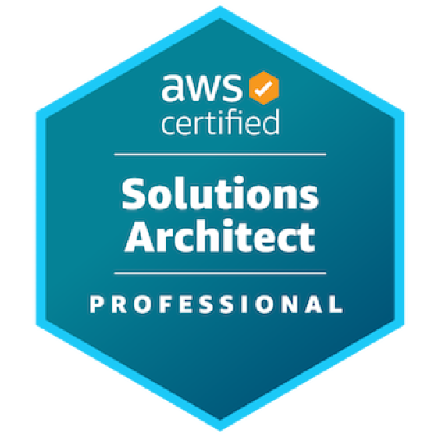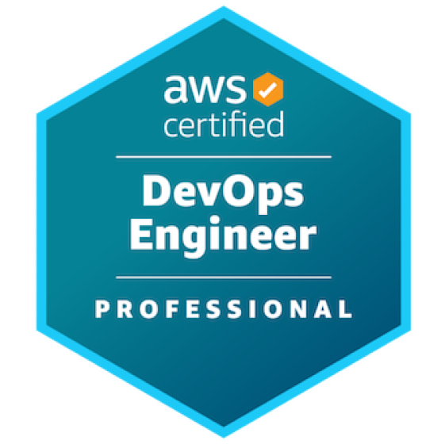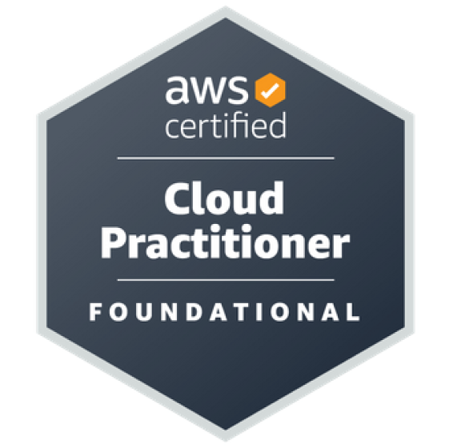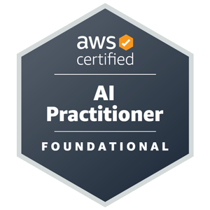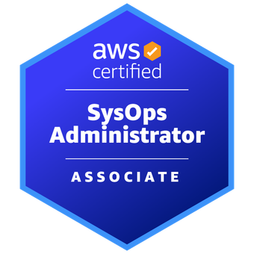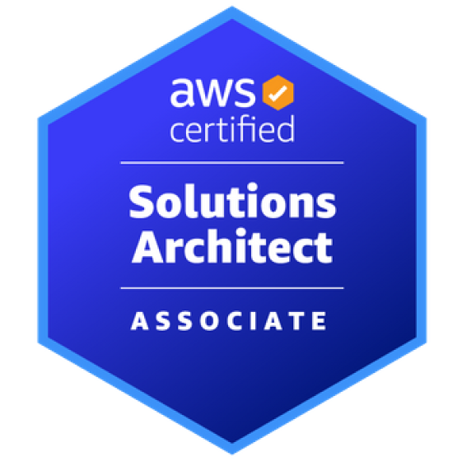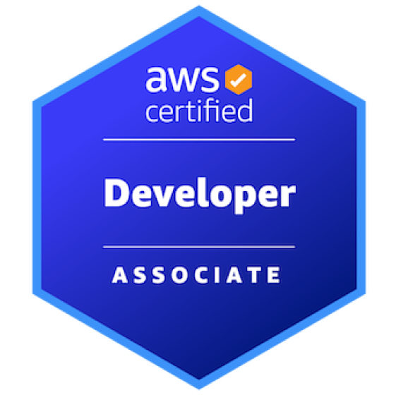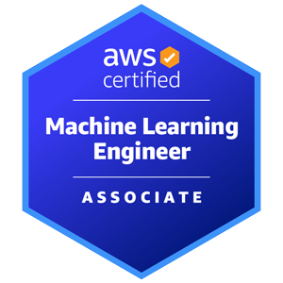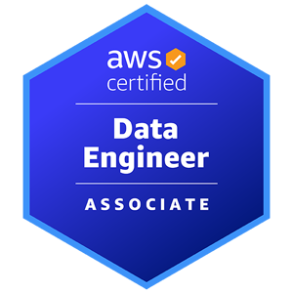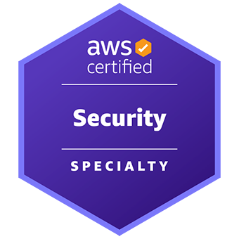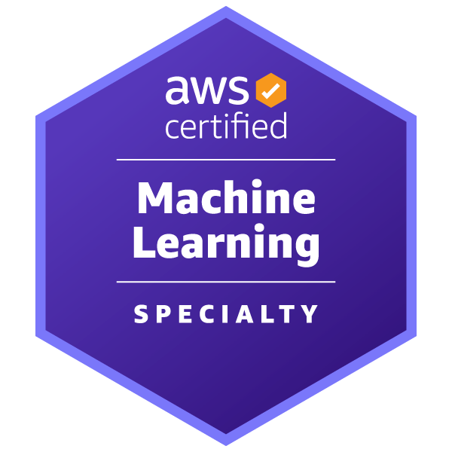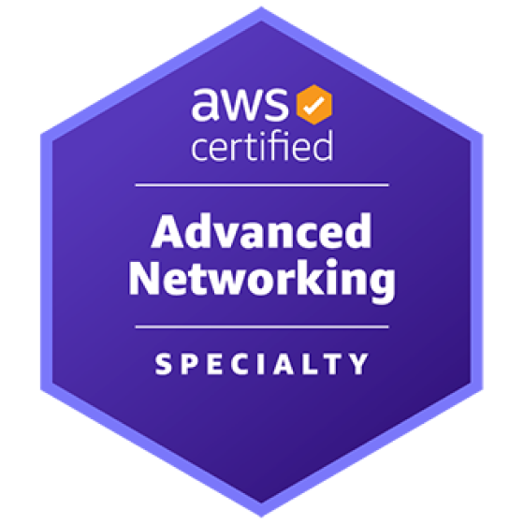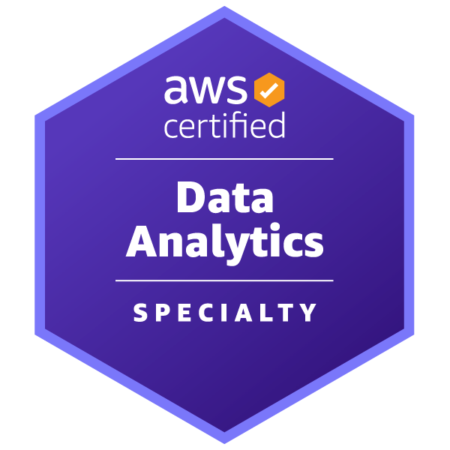

What type of companies should hire this service?
The Certified Squad is designed for organizations in a critical stage of technological evolution that need to add high-level technical capacity without halting their operations.
It’s ideal for companies that:

Have a small or overloaded technical team
Organizations that lack sufficient internal profiles or can’t allocate time to learn or execute complex AWS projects, and need a certified team to do it for them or guide them step by step.

Are already moving to the cloud but need to accelerate
Companies that are already using AWS but need to modernize, automate, optimize, or secure their environment, and can’t afford to wait to hire each profile separately.

Have accumulated technical debt and need to bring order
Businesses that have grown rapidly or without technical planning and now need to document, scale, and professionalize their architecture, without breaking what already works.

Have key initiatives blocked due to lack of resources
Companies with strategic projects that aren’t moving forward—like new integrations, pipelines, automations, or security practices; due to lack of time, focus, or specific expertise.

Want to professionalize their cloud practice
Organizations that want their AWS environment to be well-designed, secure, automated, and governed, but don’t have the internal structure to lead that transformation on their own.
With Certified Squad, you’re not hiring a temporary patch: you’re bringing in a team ready to build, deliver, and transfer knowledge.
Change doesn’t happen by improvisation. It’s executed by those who’ve already done it.

Business Case: More Capacity, Less Friction
Many organizations know what they need to do to improve their cloud operations, modernize, automate, secure, optimize; but face a concrete problem: they don’t have the team, time, or technical profiles required to do it right.
The challenge isn’t just defining the strategy; it’s having the operational capacity to execute it without slowing down the business. That’s where Certified Squad comes in.
This service is designed to solve the technical bottleneck that limits growth. Instead of waiting months to hire profiles, train your team, or try to resolve everything internally, you get a full team of AWS-certified experts, available for three months, tailored to your priorities.
What you gain with Certified Squad:
- Execution speed: your projects move forward from day one
- Strategic focus: you tackle what matters without pulling your internal team off-course
- Reduction of technical debt: you organize your architecture without improvisation
- Knowledge transfer: your team learns as we build
- Visible impact: deliverables every sprint, not vague long-term promises
It’s no longer just about having good ideas or knowing where to go.
It’s about having the right people to execute, and doing it with the quality, speed, and support your business demands.
With BigCheese, you don’t add weight, you add power.

Objective
The objective of this service is to accelerate the execution of key cloud projects by incorporating a certified AWS technical team that works alongside the client for a three-month period.
The Certified Squad helps resolve technical bottlenecks, reduce operational debt, and professionalize existing cloud environments by addressing initiatives in automation, security, observability, architecture, or data, based on business priorities.
The work is carried out in a structured way, with sprint-based deliverables, technical support, and knowledge transfer, so the client obtains measurable results and can strengthen their cloud practice with real foundations, clarity, and structure.

What We Need from BigCheese for a Successful Certified Squad
To ensure the success of the service, it is essential that the client:
- Defines clear technical priorities and objectives:
Helps us understand which initiatives are most urgent or strategic so we can properly focus the squad.
- Assigns available technical points of contact:
Internal contacts who can validate decisions, share context, and quickly resolve blockers.
- Provides access to required environments, accounts, and tools: This includes AWS accounts, repositories, testing environments, or key documentation.
- Commits to the sprint-based work dynamic:
Participates in planning meetings, demos, or deliverable validations. This doesn’t mean extra operational load, it means collaboration to move forward effectively.
- Is open to learning throughout the process:
The squad doesn’t just deliver, it also transfers knowledge to strengthen the client’s internal team.

Service Scope
The Certified Squad from BigCheese is a multidisciplinary team of AWS-certified professionals that works alongside the client for a period of three months, with an estimated workload of 120 hours, distributed in work sprints based on the project’s dynamics and objectives.
The squad includes profiles such as: Cloud Architects, DevOps Engineers, FinOps Specialists, Data Engineers, Security Specialists, SysOps, Developers, and a Project Manager or Technical Lead who coordinates the process.
The service scope is defined jointly with the client at the start of the project and may include:
- Review, documentation, and improvements to the current architecture
- Automation of processes and pipelines (CI/CD, IaC, backups, dataflows)
- Implementation or improvement of DevOps practices and observability
- Account organization and governance (AWS Organizations, SCPs, tagging)
- Cost optimization and adoption of a FinOps culture
- Security and compliance reinforcement (IAM, encryption, alerts, posture)
- Design and activation of data solutions (lakehouse, pipelines, cataloging)
- Development of specific features or support in targeted initiatives
- Review of deployment and operations standards
- Design of production, staging, or development environments
- Integration between services and internal tools
- Creation of reproducible environments for new projects
- Improvement of access control and authentication practices
- Preparation for security or compliance audits
- Implementation of workflows across technical teams
- Refactoring or separation of tightly coupled services
- Support in technical roadmaps for modernization or expansion
Task prioritization is done jointly and organized in a backlog, with partial deliverables validated at the end of each sprint.
The entire process is documented and knowledge is transferred to the client’s team to ensure continuity or scale-up of the work performed.

Success Criteria
To consider the Certified Squad service successful, the following measurable and verifiable criteria, agreed upon with the client, must be met:
- Sustained progress on the prioritized technical backlog
Tasks defined at the beginning of the project are executed as planned in each sprint, with concrete and validated deliverables.
- Effective knowledge transfer
The client’s team receives support, technical explanations, and useful documentation on the changes made, tools used, and best practices adopted.
- Reduction of technical bottlenecks
Previous blockers that prevented progress on key projects or impacted daily operations are removed..
- Visible improvement in at least one critical dimension
Whether it's security, automation, operational efficiency, monitoring, or governance, the client perceives applied technical improvements with tangible impact.
- Smooth collaboration between teams
A healthy work dynamic is established between the squad and the client’s internal team, without friction or delays.
- Client technical team satisfaction
Internal technical leads value the process, the results, and the quality of the work delivered, confirming that the squad was a real help, not an additional burden.
- Installed capacity to continue
The client is left with the knowledge, documentation, and technical foundations to continue or scale the initiatives addressed, without depending solely on the squad.

Deliverables
The work of the Certified Squad is organized in 1- or 2-week sprints, depending on the client’s dynamics and needs.
Each sprint includes defined technical objectives, prioritized tasks, and a clear deliverable at the end, which is validated with the client’s team.
During the engagement period, the following types of deliverables are generated:
- Prioritized technical backlog
Built jointly with the client at the beginning of the service and refined sprint by sprint based on progress and newly identified needs.

- Sprint planning
A document or board outlining tasks to be executed, assigned owners, dependencies, and acceptance criteria..
- Technical deliverables per sprint
These may include implementations, configurations, documentation, applied improvements, or reusable scripts, always with functional evidence of the change made.

- Progress Demo
At the end of each sprint, a review is held with the client team to showcase what was done, how it was done, and the value it brings.
- Technical and Operational Documentation
We document the decisions made, the architectures proposed or implemented, critical configurations, and adopted best practices.
- Executive Impact Report (optional at closure)
A summary of the progress achieved, improvements implemented, the value delivered across technical dimensions (security, performance, automation, etc.), and recommendations for next steps.
Deliverables are continuously reviewed and validated within an agile, collaborative, and transparent framework.
Our focus is not just on completing tasks, it's on generating impact, sprint by sprint.

Team involved
The Certificated Squad is made up of AWS-certified professionals, assigned according to the client’s specific needs and the objectives defined for each sprint. Below are the most common roles within the team:
- Project Manager / Technical Lead
Responsible for managing, coordinating, and tracking the team and project activities. Facilitates communication with the client, organizes sprints, and ensures that deliverables are completed on time and to standard.
- Solutions Architect
In charge of designing architectures on AWS, applying best practices from the Well-Architected Framework. Defines patterns, key decisions, and technical guidelines to ensure scalability, security, and efficiency.
- Cloud Engineer
Responsible for implementing cloud services and executing technical tasks aligned with the architectural design. Participates in automation, configurations, and deployments.
- DevOps Engineer
Handles pipelines, infrastructure as code, deployment automation, and operational efficiency improvements. Supports continuous integration and continuous delivery (CI/CD).
- FinOps Specialist
Supports financial management of cloud resources. Identifies cost-saving opportunities, improves spend visibility, and promotes a FinOps culture across the organization.
- Security Specialist
Evaluates and strengthens the security posture of the AWS environment. Implements controls, access policies, encryption, and threat monitoring.
- Data Engineer / Data Architect
Participates in designing and building data pipelines, data modeling, storage solutions, cataloging, and data exploitation.
The specific composition of the squad is tailored to each client, always prioritizing impact, agility, and technical depth.

Plan de acción
Month | Activity
Month 1 | Kick-off with stakeholders, definition of objectives
Month 1 | Technical assessment and diagnosis of current state
Month 1 | Identification of quick wins and backlog planning
Month 1 | Implementation of initial improvements (quick wins)
Month 1 | Technical review and validation with client
Month 1 | Initial documentation and first technical guidelines
Month 2 | Implementation of prioritized tasks (technical backlog)
Month 2 | Mid-sprint technical validation + adjustments
Month 2 | Technical support in critical environments or bottlenecks
Month 2 | Operational documentation and technical guidelines
Month 2 | Partial Technical Knowledge Transfer
Month 3 | Completion of ongoing tasks + backlog closure
Month 3 | Full documentation of implemented work
Month 3 | Final knowledge transfer
Month 3 | Project closure and executive impact presentation

Total hours allocated: 120 hours

Cronograma estimado
 | Month 1 |  |  |  | Month 2 |  |  |  | Month 3
Activity | S1 | S2 | S3 | S4 | S5 | S6 | S7 | S8 | S9 | S10 | S11 | S12
Kick-off with stakeholders, definition of objectives
Technical assessment and diagnosis of current state
Identification of quick wins and backlog planning
Implementation of initial improvements (quick wins)
Technical review and validation with client
Initial documentation and first technical guidelines
Implementation of prioritized tasks (technical backlog)
Mid-sprint technical validation + adjustments
Technical support in critical environments or bottlenecks
Operational documentation and technical guidelines
Partial technical knowledge transfer
Completion of ongoing tasks + backlog closure
Full documentation of implemented work
Final knowledge transfer
Project closure and executive impact presentation

Budget

Total team hours: 120 hours

Price: USD 12,000 + VAT
Through AWS Marketplace: 50% discount
Final price: USD 6,000 + VAT

What happens after the 3-month Squad engagement?
At the end of the three-month period with the Certificated Squad, we assess the progress, learnings, and outcomes together with the client. Based on this evaluation, three possible paths are available:
- Continue with the current Squad
If the approach and dynamics worked well, the service can be renewed for another three-month cycle, maintaining the same structure or adjusting roles based on new priorities.
- Scale to a more intensive plan
If faster execution or broader scope is needed, the team can be expanded or the hours per sprint increased.
- Activate a goal-specific Squad
Depending on upcoming challenges (e.g., cost optimization, architecture modernization, data solutions, or security), a specialized Squad can be assembled to target that specific objective.
- Close the service
If the goals were met and the client now has the internal capacity to continue independently, the service can be concluded with no further commitments.
With BigCheese, continuity is not an obligation, it’s a well-informed decision based on real results. Scale, adjust, or close: it all depends on your goals.

